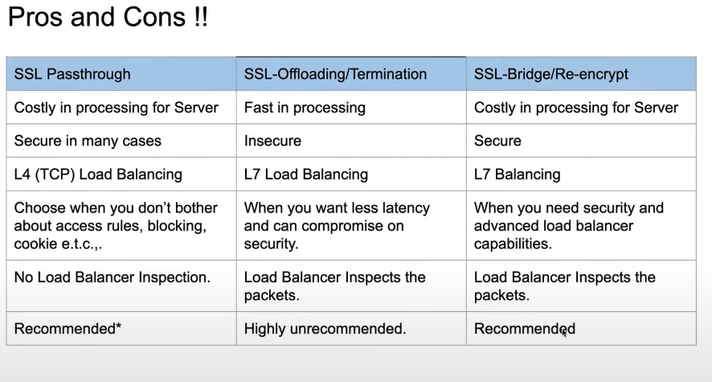

AWS Zero to Hero : Day 7 :

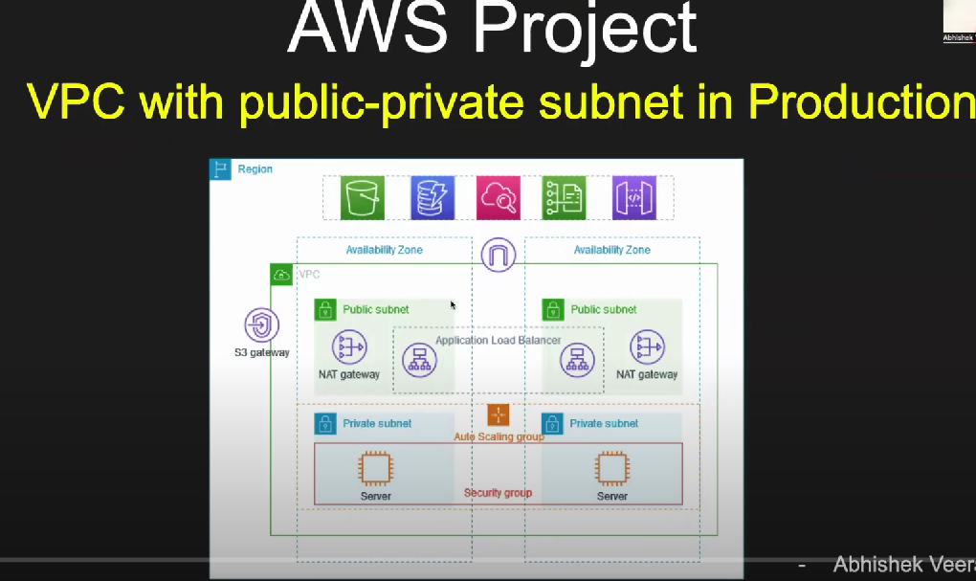

AWS Interview :

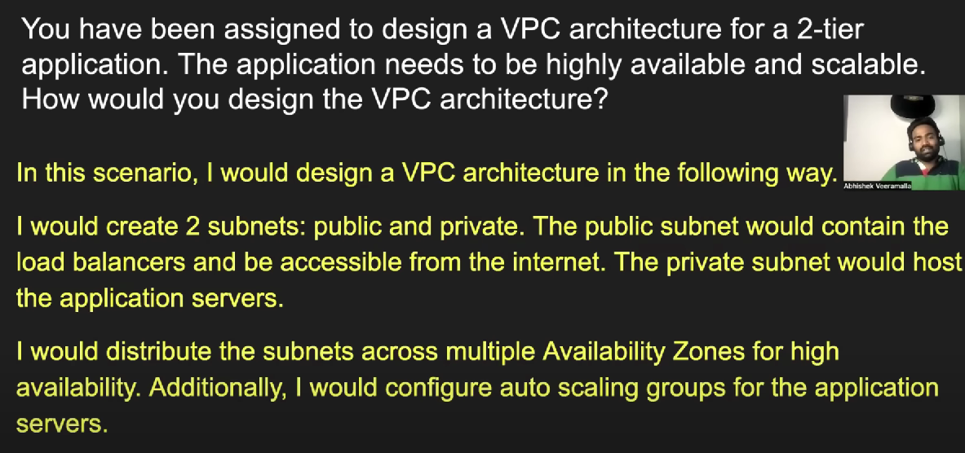

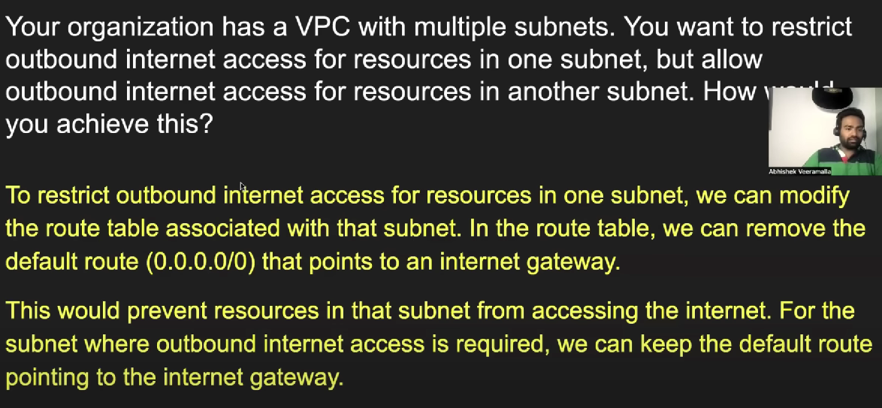

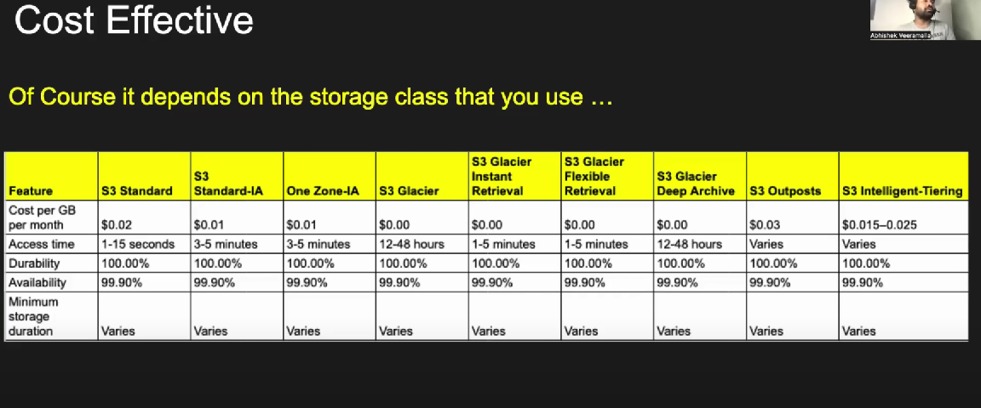

Day 10 : CLI command to create EC2 instance



Day 13:

AWS CI/CD :

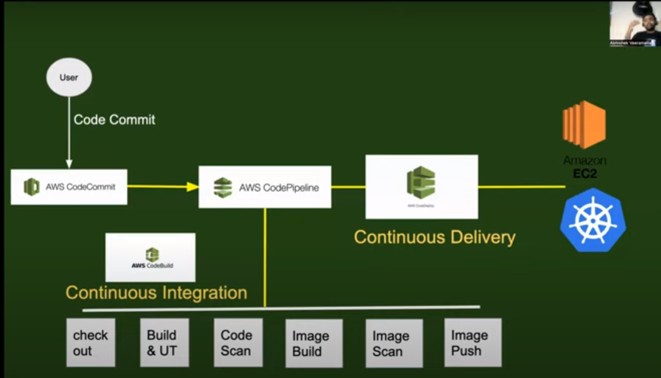

CI/CD ( Open tools )

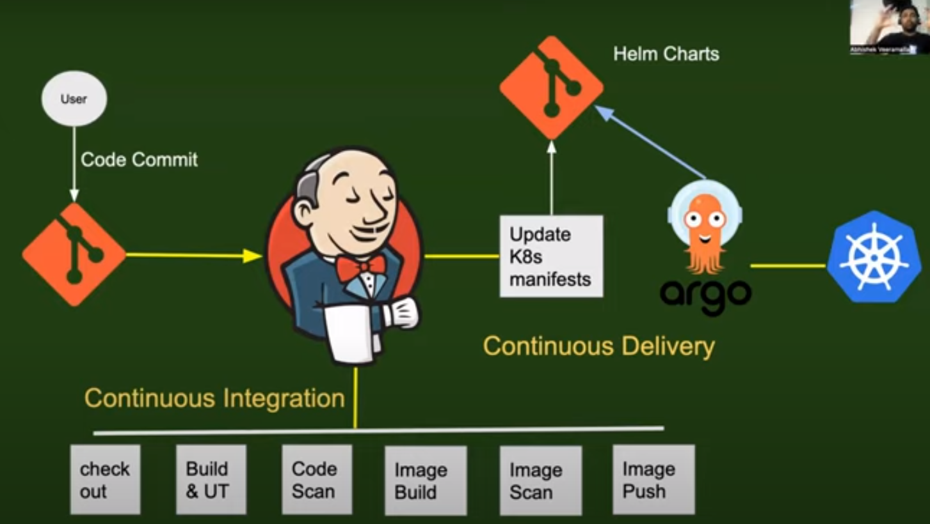

K8s installation :

Before running step3 , we can run kubeadm join in worker nodes separately to add in Kubernetes cluster

